Open Group policy management

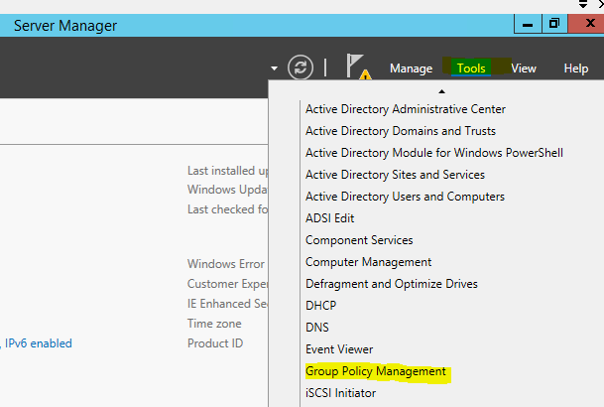

Right Click the default domain policy and Edit it

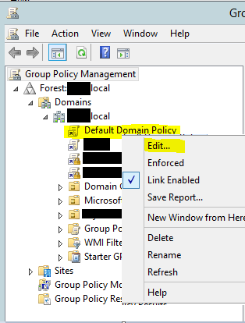

Navigate to Trusted Root Certification Authorities

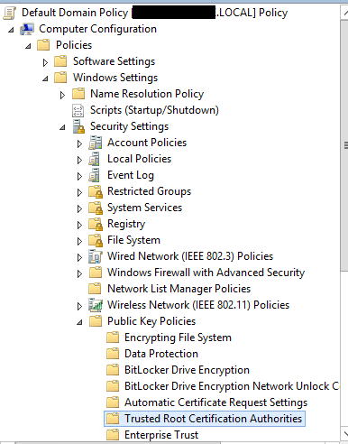

Right click Trusted Root Certification Authorities and choose import

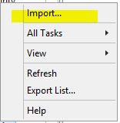

Select Local Machine

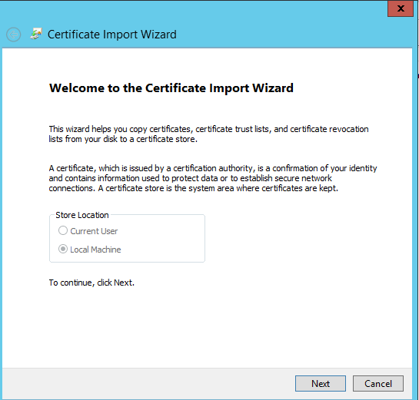

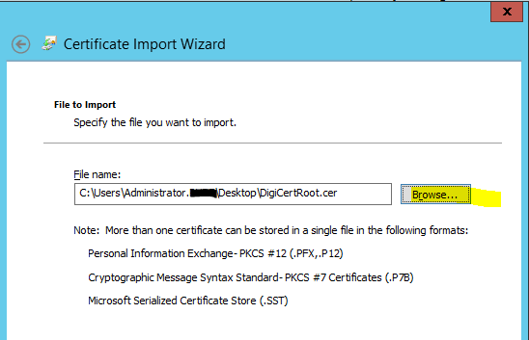

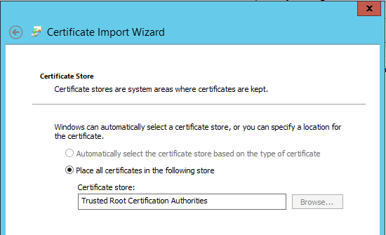

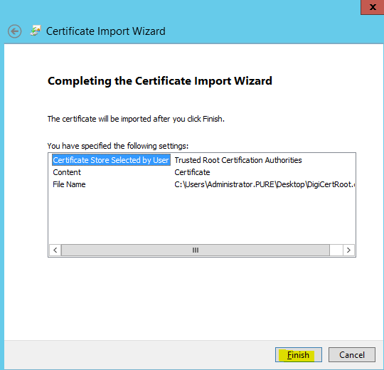

You should see the certificate in the right hand pane.

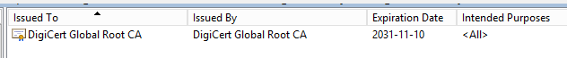

On affected PCs, you can either restart or from an administrative command prompt run the following:

Gpupdate /force

Then restart Outlook.